**Open a Terminal window.**

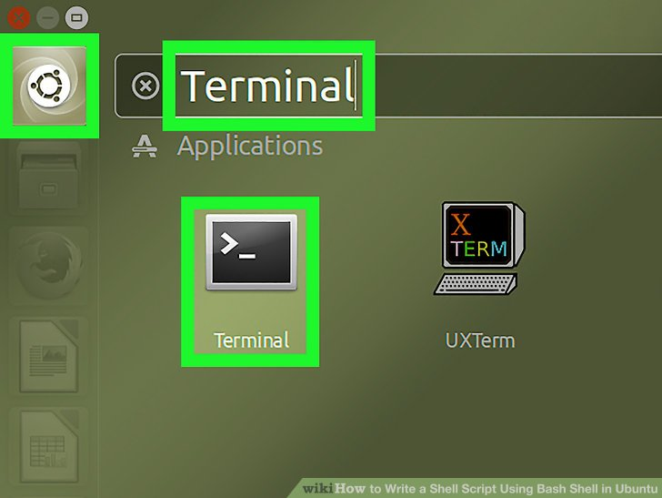

### Create a file with your text editor.

### Begin your script.

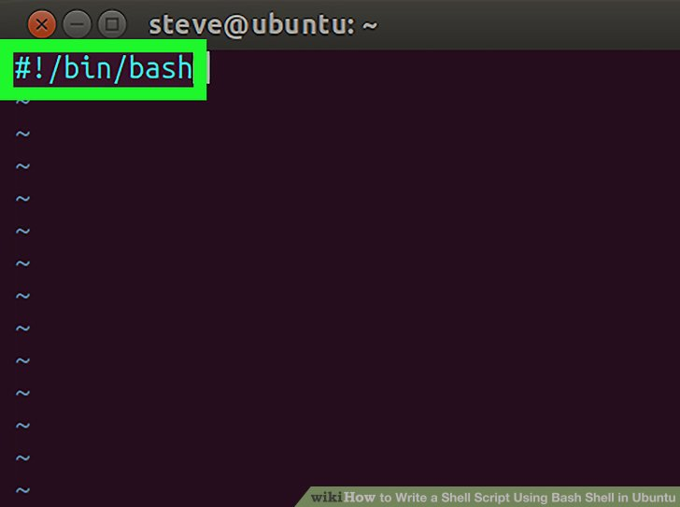

### Type the code.

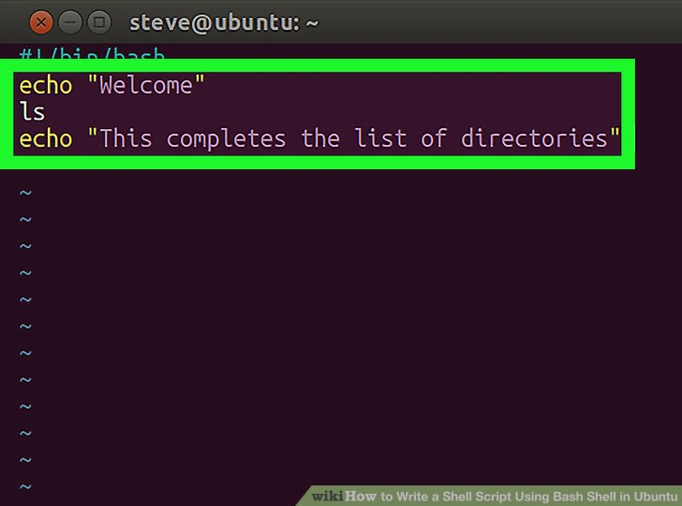

EXIT VIM

**Exit vim.** Type **Esc**, then **:**, and then + **wq** to save and quit. This will write the changes to the file and bring you back to the terminal. Save the file as ListDir.sh

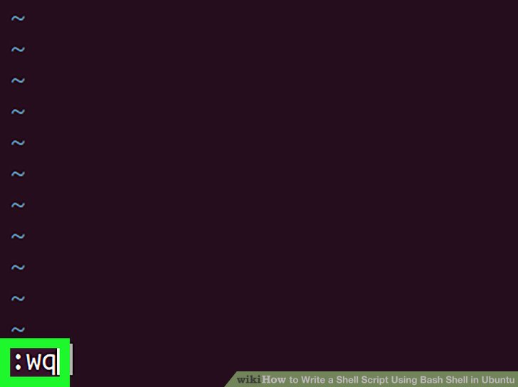

### Make the script executable.

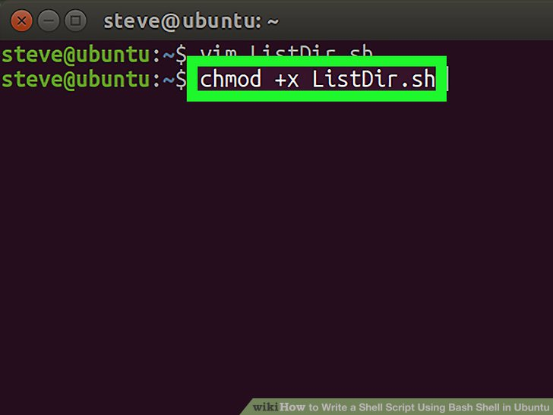

### Run your shell script.

